**QA of Food Operation Inspection and General Sanitation Inspections**

Once surveyor has completed data input, they **do not** change the status.

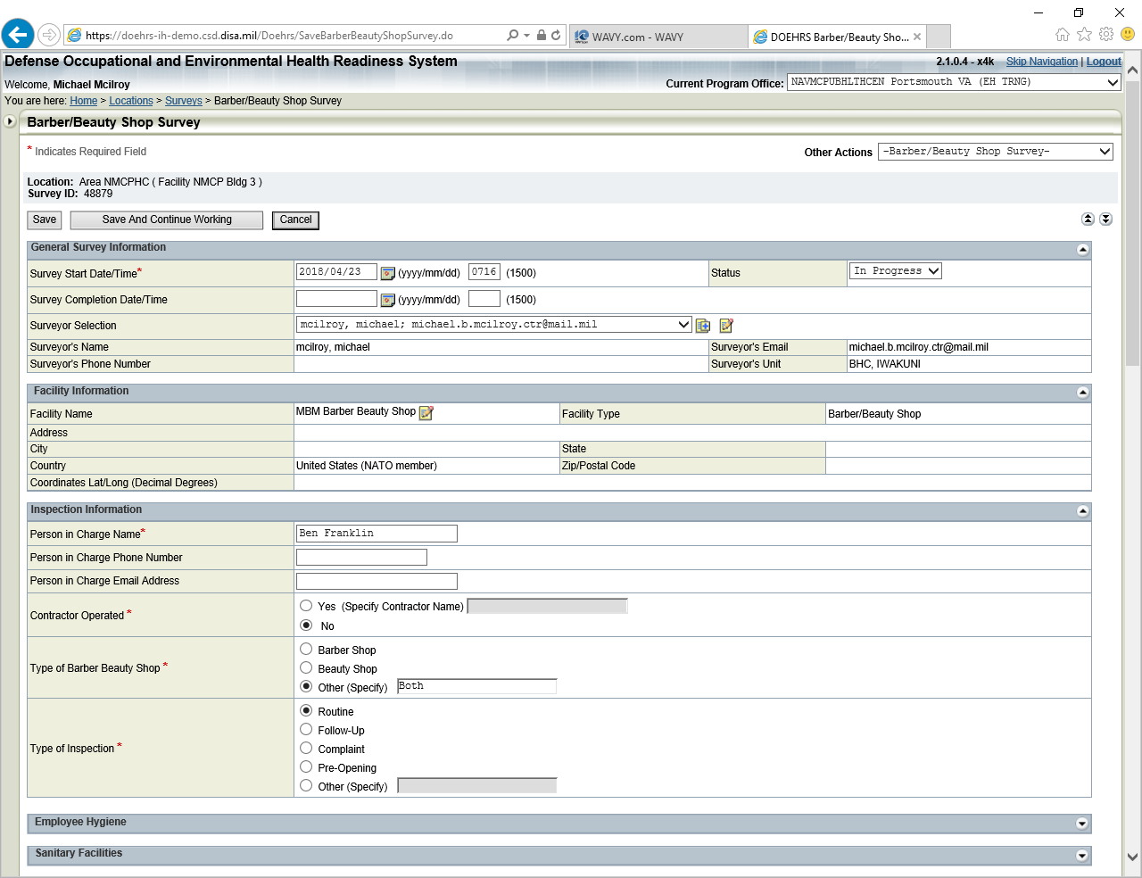

Surveyor goes to bottom of form and changes “Responsible Program Office Personnel” to whomever is designated as QA.

That person now has control of the form. The form status can be changed to “Completed” or if errors noted can be sent back to surveyor by making them the “Responsible Program Office Personnel” and click save.

The QA person would then notify the surveyor in person, via email or phone of the need to make corrections. Once corrections are made then the surveyor would again change the “Responsible Program Office Personnel” to the designated QA.

Once the form is marked “Completed” it is locked.

